Dominic Drury

05/28/2024

CS-405

4-2 Milestone: Unit Testing

Screenshot of Unit Test Run Results

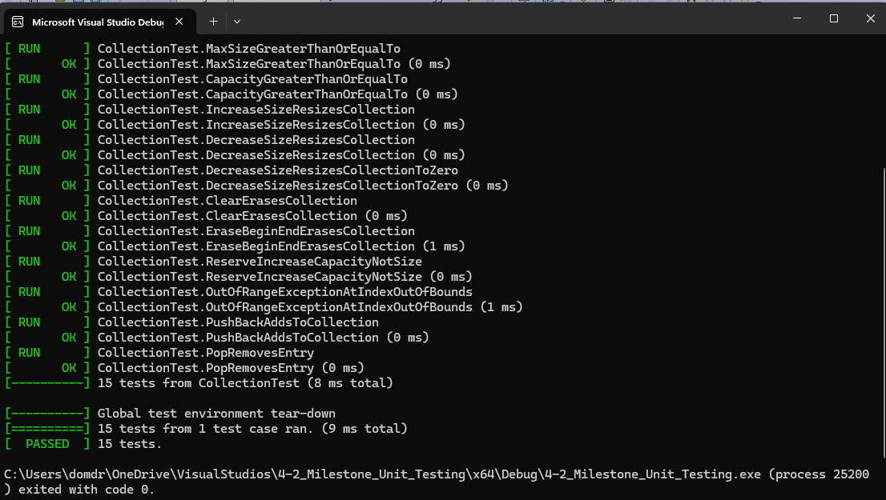

Following the instructions for creating the tests that were already defined was a relatively straightforward task but coming up with 2 of my own tests was incredibly tricky for me. I am still not sure that I created a positive and negative test and am worried that I came up with 2 positive tests, but all the exception tests I tried to implement I could not figure out how to. One of my failed ones that I could not get to work was trying to ensure that an exception was thrown if an entry was added to the collection if it was already at its max, I think because the max size was larger than the int count for the add entry, and any attempt to exceed that triggered its assert. In the end I came up with a test that verified that something was true, and something was not true.